Magdalene Preschool - Children’s own policy
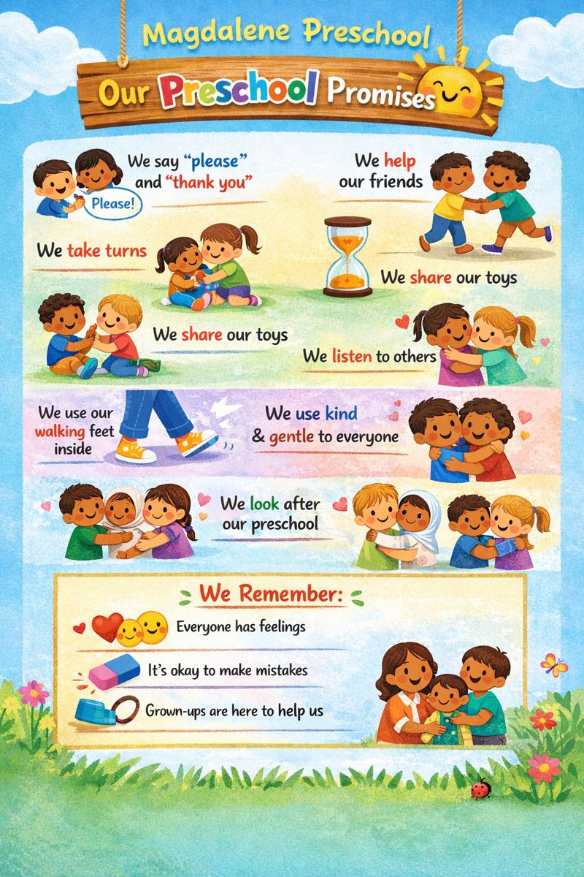
Children are supported to share concerns and seek help from trusted adults. Staff respond appropriately and ensure children feel safe, listened to and supported, in line with safeguarding procedures.

